Analyze business process data from SAP Analytics Cloud and create a performance report

Step 1: Analyze Visualizations

- Chart 1: PO Processing Time (Days): (provided) The chart shows the PO processing time for each supplier. FurryStyle Co has the longest PO processing time at 102 days, while FelineFoods Inc has the shortest at only 17 days. The other suppliers have processing times ranging between 32 and 85 days.
- Chart 2: Total invoice amounts by vendor: This chart tracks the total monetary value of all invoices submitted by each vendor to evaluate the volume of spend across the supplier base.
- Chart 3: Invoice Cycle Time by vendor: This chart measures the average number of days between the date goods are received and the date the vendor’s invoice is received.
- Chart 4: Payment Amount by vendor: This chart displays the total actual payments made to each vendor to monitor cash outflows and payment fulfillment.

Step 2: Interpret KPIs

- Chart 1: PO Processing Time (Days): (provided) PO Processing Time (in days) is the KPI. Lower times indicate more efficient order handling. FelineFoods Inc is the most efficient, while FurryStyle Co is the least efficient.
- Chart 2: Total invoice amounts by vendor: This KPI represents the scale of procurement from each vendor. A high invoice amount indicates a major supplier relationship and significant spend, which is critical for vendor spend analysis.
- Chart 3: Invoice Cycle Time by vendor: This KPI measures billing efficiency. A short cycle suggests the vendor bills promptly, whereas a long cycle could indicate bottlenecks in invoice generation or internal receipt delays.
- Chart 4: Payment Amount by vendor: This KPI reflects financial fulfillment. Comparing this to the invoice amount helps identify payment patterns; any discrepancy may suggest short-payments or unresolved invoice disputes.

Step 3: Draw Conclusions
- Chart 1: PO Processing Time (Days): (provided) Supplier efficiency in PO processing varies greatly. FelineFoods Inc is the fastest, while FurryStyle Co's very long processing time (102 days) is a major concern. Buyers should consider these differences in their supplier management.
- Chart 2: Total invoice amounts by vendor: High invoice amounts from specific vendors indicate that Scaredy Cat Supplies relies heavily on these partners. These high-spend relationships should be prioritized for performance audits and contract negotiations to ensure the best value.
- Chart 3: Invoice Cycle Time by vendor: Vendors with long invoice cycle times delay the recognition of liabilities and can negatively affect cash flow forecasting. Shortening these cycles is essential for better financial planning and maintaining a steady P2P process.
- Chart 4: Payment Amount by vendor: Any significant gaps between payment amounts and invoice amounts suggest the existence of unresolved disputes or payment errors. Regular reconciliation is required to ensure financial transparency and maintain healthy vendor relations.

Step 4: Create a Performance Report

Executive Summary The analysis of Scaredy Cat Supplies’ procure-to-pay process reveals a significant performance gap among suppliers. While FelineFoods Inc demonstrates high efficiency with a 17-day PO processing time, FurryStyle Co serves as a major bottleneck with 102 days. Key findings suggest that inconsistent invoice cycle times and discrepancies in payment amounts are hindering cash flow predictability and operational agility.
Introduction This report evaluates the procure-to-pay cycle for Scaredy Cat Supplies to identify inefficiencies from initial requisition to final vendor payment. The scope of this analysis focuses on key performance indicators (KPIs) such as PO processing time, invoice cycle times, and the alignment between invoice and payment amounts.
Data Interpretation and KPI Analysis
- Average PO Processing Time by Vendor: FurryStyle Co is the least efficient at 102 days, whereas FelineFoods Inc is the most efficient at only 17 days.
- Invoice Cycle Time (Days) per Vendor: Long cycles indicate potential billing delays from vendors or internal bottlenecks in processing received goods.
- Invoice Amount per Vendor: This identifies high-spend vendors where Scaredy Cat Supplies has significant procurement volume and strategic dependency.
- Payment Amount per Vendor: Monitoring actual payments reveals if financial obligations are met or if unresolved invoice disputes exist.
Key Trends and Insights A clear pattern shows that vendors with extremely long PO processing times, such as FurryStyle Co, also tend to create volatility in the procurement schedule. These outliers significantly increase the average lead time, suggesting a need for more standardized supplier agreements.
Recommendations
- Supplier Performance Management: Conduct a formal review with FurryStyle Co to investigate the causes of their 102-day processing delay and set mandatory performance targets.
- Process Automation: Implement automated reconciliation between invoice and payment amounts to quickly identify and resolve financial discrepancies.
Conclusion The P2P process at Scaredy Cat Supplies is currently hindered by extreme variances in supplier efficiency. Addressing the outliers and standardizing invoice cycles will be critical for streamlining operations and ensuring timely payments across the supply chain.
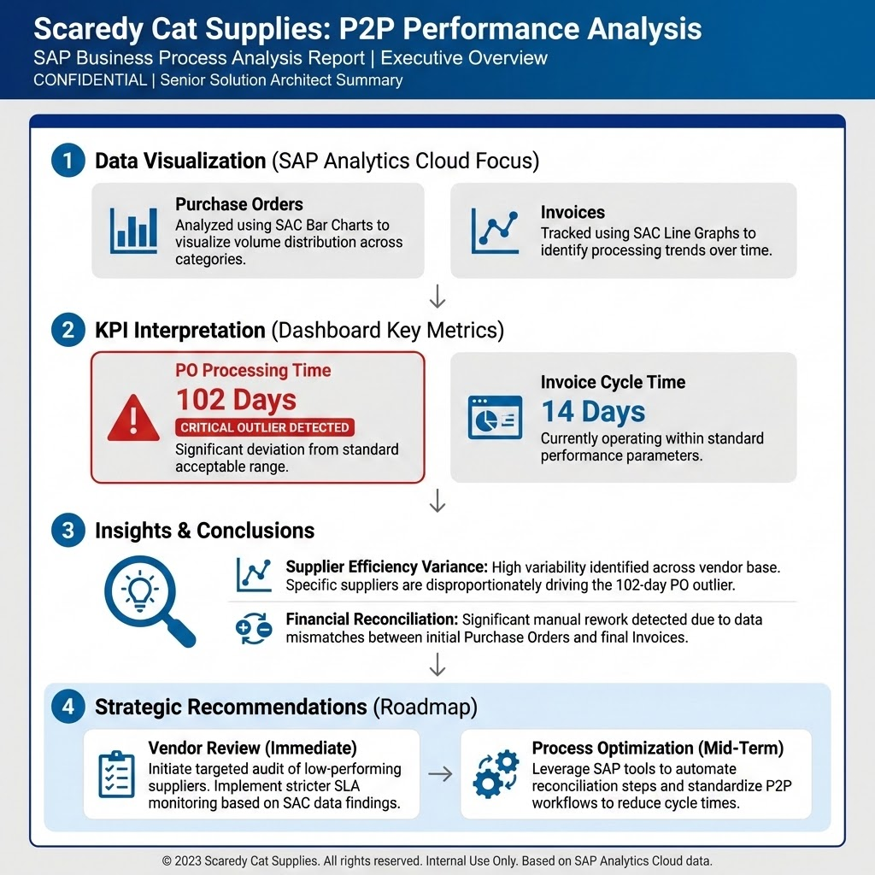
Technical Infographic Title:

SAP P2P Performance Deep Dive: Mitigating Extreme Vendor Volatility

Detailed Technical Commentary (for Document Caption or Comment Thread):

This infographic summarizes the Procure-to-Pay (P2P) process analysis, highlighting critical performance disparities identified via SAP Analytics Cloud (SAC) data. The core finding is a significant supplier performance gap which severely compromises operational efficiency and cash flow predictability.

Key Performance Indicators (KPIs) and Outliers:
The primary bottleneck is the PO Processing Time, evidenced by the 102-day outlier from FurryStyle Co, which contrasts sharply with the most efficient vendor, FelineFoods Inc, at 17 days. This extreme variance in lead time introduces volatility into the procurement schedule, necessitating immediate supplier management intervention.

Financial and Operational Insights:
Analysis of the data indicates that inconsistent Invoice Cycle Times contribute to delayed recognition of liabilities, thereby negatively impacting cash flow forecasting. Furthermore, monitoring the alignment between Total Invoice Amounts and Payment Amounts reveals discrepancies that suggest unresolved disputes or payment errors, stressing the need for mandatory, regular financial reconciliation to ensure transparency.

Strategic Recommendations:
The data mandates a dual-pronged corrective strategy:
- Supplier Performance Management: Conduct a formal performance review with FurryStyle Co to address the 102-day processing delay and enforce mandatory performance targets.
- Process Automation: Implement automated reconciliation features within the P2P system to rapidly identify and resolve financial discrepancies between invoice and payment records, thus streamlining the overall process.

